



DATABASE APPLICATIONS
(240)
NATIONAL 2021

Production:
Job 1: Ticket Table __________ (100 points)
Job 2: Donor Table __________ (100 points)
Job 3: Countdown Report __________ (50 points)
Job 4: Relationship Report __________ (100 points)
Job 5: Sales Query and Report __________ (100 points)
TOTAL POINTS __________ (450 points)

Test Time: 90 minutes

SCORING GUIDELINES
Unless indicated otherwise, student receives all points or none | Points Possible | Points Earned
Job 1: Tickets Table
Correct field names (2 points each) | 10
Data entry (5 points per record) | 40
Correct calculated field | 15
Best fit columns and printed on one page | 20
Named Tickets xx-xxxx-xxxx | 15
Subtotal Job 1 | 100
Job 2: Donor Table
Correct field names and data types | 10
Correct data entry (5 points per record) | 45
Printed in landscape view | 10
Field names and data are visible and printed on one page | 20
Named Donor xx-xxxx-xxxx | 15
Subtotal Job 2 | 100
Job 3: Countdown Report
Display Each Ticket Type and Remaining Tickets | 20
Add calculated field for Grand Total | 20
Printed on one page | 5
Named Countdown xx-xxxx-xxxx | 5
Subtotal Job 3 | 50
Job 4: Relationship Report
One to One relationship created Between Orders and Donors | 20
Enforce Referential Integrity | 10
One to Many relationship created Between Tickets and Orders | 20
Enforce Referential Integrity | 10
Printed with all tables full visible | 10
Printed on one page | 15
Named Relationship xx-xxxx-xxxx | 15
Subtotal Job 4 | 100
Job 5: Sales Query and Report
Calculate Sales | 15
Report is Portrait and Block style | 15
Display Ticket Name, Sales, First Name, Last Name, and Business Phone fields | 20
Viewed by Sales data, grouped on Ticket Name | 15
Sorted in descending order based on Sales then by Last Name, First Name in ascending order | 20
Named Sales xx-xxxx-xxxx | 15
Job 5 Subtotal | 100
Total Points Earned | 450

JOB 1: TICKET TABLE
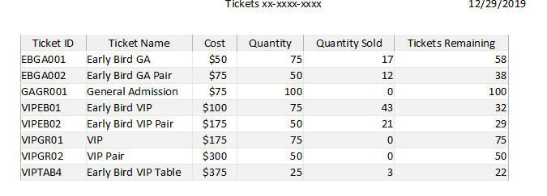
JOB 2: DONOR TABLE
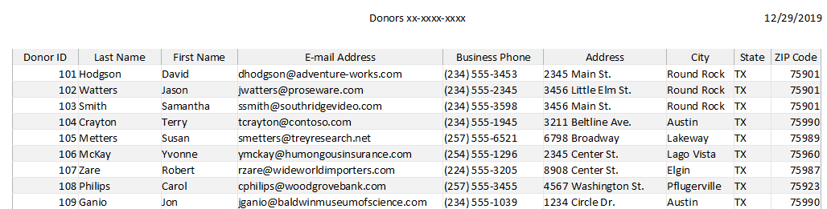
JOB 3: COUNTDOWN REPORT
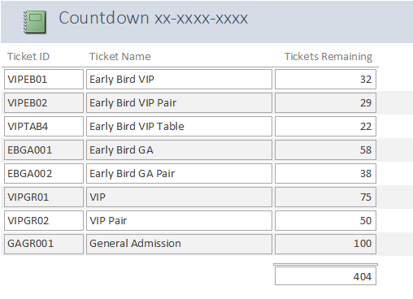
JOB 4: RELATIONSHIP REPORT
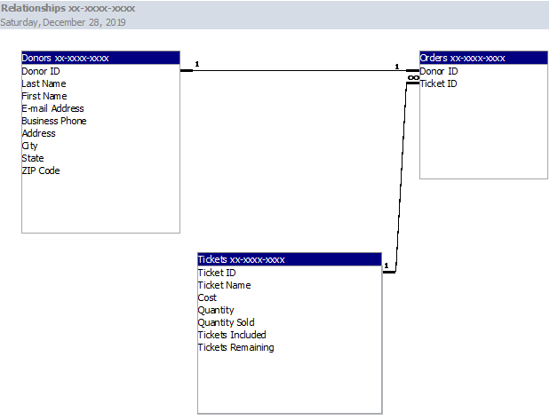
JOB 5: SALES QUERY AND REPORT
